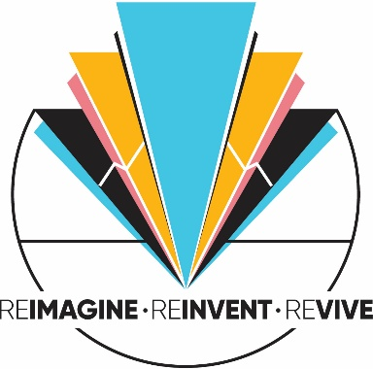
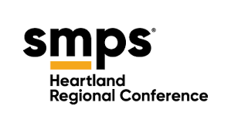

2026 Heartland Regional Conference
PINNACLE AWARDS APPLICATION
The online application does not allow you to save your application progress. Please use this document to support the assembly of your 2026 Pinnacle Award Application.

CONTACT INFORMATION

First Name: Point of contact for questions regarding the application
Last Name:
Job Title:
Email Address:
Phone Number:
Company Name:
Company Address:
Company Website:

Additional Information: Please list additional project team members or firms you created this project with. (500 characters)

Are you an SMPS Member?: yes/no

Chapter Affiliation:
Must be one of: Chicago, Greater Cincinnati, Columbus, Indiana, Kentucky, West Michigan, Southeast Michigan, Northeast Ohio, Twin Cities, or Wisconsin.

PROJECT ENTRY INFORMATION

Category:
- Holiday Piece
- Promotional Campaign
- Special Event
- Digital Marketing and Online Presence
- Thought Leadership and Content Marketing
- Community Impact and Outreach
- Client Experience (CX) Initiatives
- Brand Development

Entry Title: Please enter the name of your entry including your firm name.
Naming Convention: Name of Firm_Name of Project

Completion Date for Project: All entries must be completed between January 2024-January 2026

Role of primary contact:
(e.g., marketing lead, designer, strategist, coordinator)

Digital/Mixed Media URL:
Required for all digital and mixed media entries. For example video or website entries.

Do you have additional URLs to submit?
Yes/No - If you would like to submit additional URLs for the jurors to view, please click the YES option and you will be prompted to enter additional URLs.

PDF Document Upload:
Required for all printed materials accompanying the project you are submitting. Please upload PDFs for all print and some digital screenshots. In addition, PDFs may be required for categories that ask for supporting documentation such as marketing, strategic or media plans.

Use naming convention: ProjectName_FirmName.pdf
Example: 123MarketingPlan_ArchitectureA.pdf

Entry Image Upload #1 -#3
Entry Images will be the image showcased in the Pinnacle Awards Gallery on the HRC Website and on Social Media as well as during the Awards Ceremony during the conference. All images uploaded will be used for judging purposes. Make sure to upload a clean, clear image that best represents your entry. Use the fields below to upload additional images to illustrate your entry best. A minimum of 3 different images is required for all entries.
Specifications: File size must be under 5 MB. 300 dpi, 3000 pixels for either width or height measurement.

Additional images to submit?
☐ Yes ☐ No

ENTRY QUESTIONNAIRE
The responses to the following questions will be judged by our jurors while evaluating your entry. You may use bullets to list your answers.

Creative Brief (1,750 characters max)
Please give a high-level, creative summary of your entry explaining the purpose of the piece or campaign, core creative idea, why it was developed and why it was successful.

Strategic Alignment (500 characters max)
What did your firm hope to achieve with the piece or program?
How did you define success?
How did you plan to measure results?
Include the following information:
- Marketing objectives
- Specify the timeframe
- Budget/Resource Information
- Methodology for collecting and evaluating results

Target Audience (500 characters max)
Explain:
- Who the piece or campaign was designed to reach
- Audience size, segmentation, and location
- Analytical goals (if digital)

Be sure to characterize the composition, size and location of your target audience (for example: 250 CEOs and senior managers of the top 500 leaders of the Indiana high-tech industry)

Market Research, Planning and Implementation (500 characters max)
Describe the market research conducted prior to planning your piece or campaign. Summarize your marketing plan efforts. Explain the production and delivery method.

Intended Message / Call to Action (500 characters max)
Describe the intended message or call to action of this entry? What are you trying to convey or communicate to the audience through this marketing piece?

Effectiveness (500 characters max)
Explain:
- Why this concept is distinctive or original in the AEC industry
- How the messaging aligned with the target audience
- How branding/identity was incorporated appropriately

Results (500 characters max)
Summarize the results and how you measured success, such as:
- Engagement metrics
- Analytics
- Participation numbers
- Testimonials
- Before/after comparisons
- Audience response
- Feedback or measurable actions taken

Which actions did the target audience take after receiving your materials? (testimonials/feedback)
(500 characters max)
Did you meet the specific goals set in your marketing objectives? If not, what would you have improved or changed about your piece?
(500 characters max)

Resource Summary (500 characters max)
In 100 words or less, describe the resources available for this effort—including budget, staffing, tools, and time—and explain how you used them efficiently and strategically. Note any constraints and how they shaped your approach or outcomes.

Additional Information (Optional Field) (500 characters max)
If you need to share more instructions or information for the jurors to review for your entry, please use the text box below.
Use this space for any context, clarifications, or supplemental explanations that would help jurors fully understand your submission.

ATTESTATION
☐ I confirm all information submitted is accurate.
☐ I verify that all materials comply with copyright requirements.
☐ I authorize SMPS to use project images and materials for educational and promotional purposes.

